# Amazon Machine Image

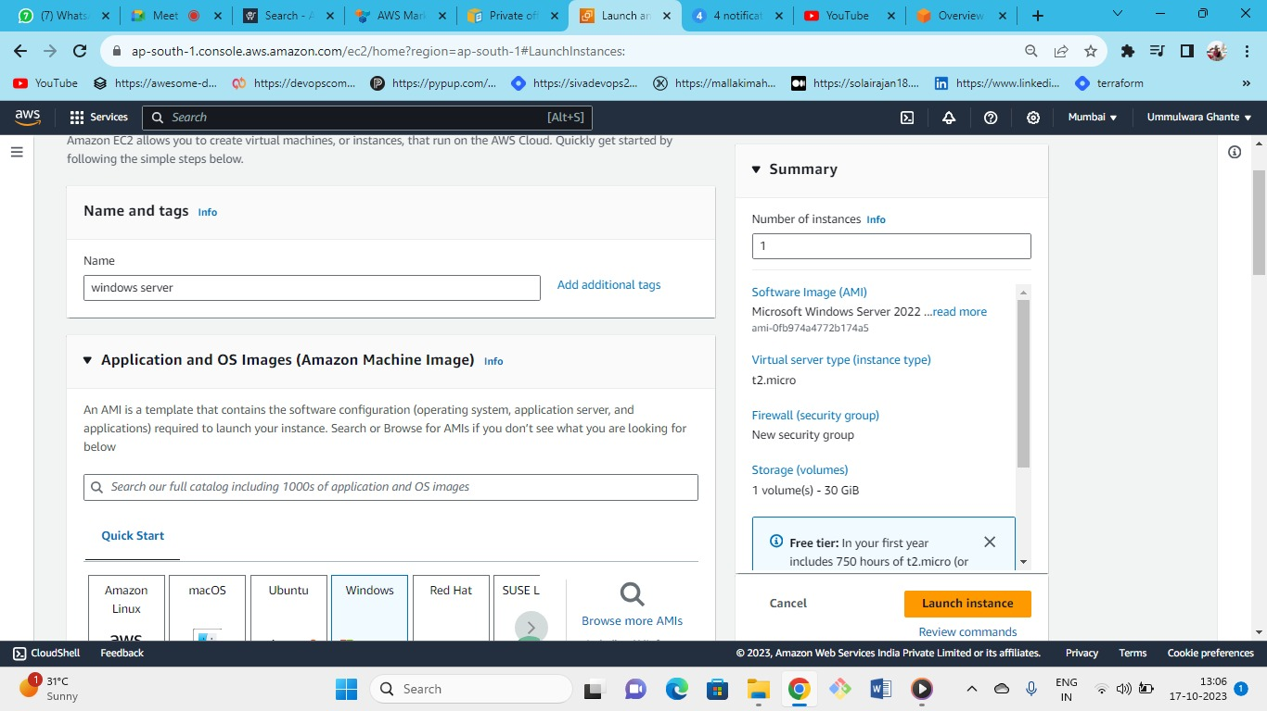



* OS (windows)--->instance type (t2.micr0) ---> keypair(create new or keep old one) ---> security group (new or existing)-->storage(gp3)--->launch
* Launch instance

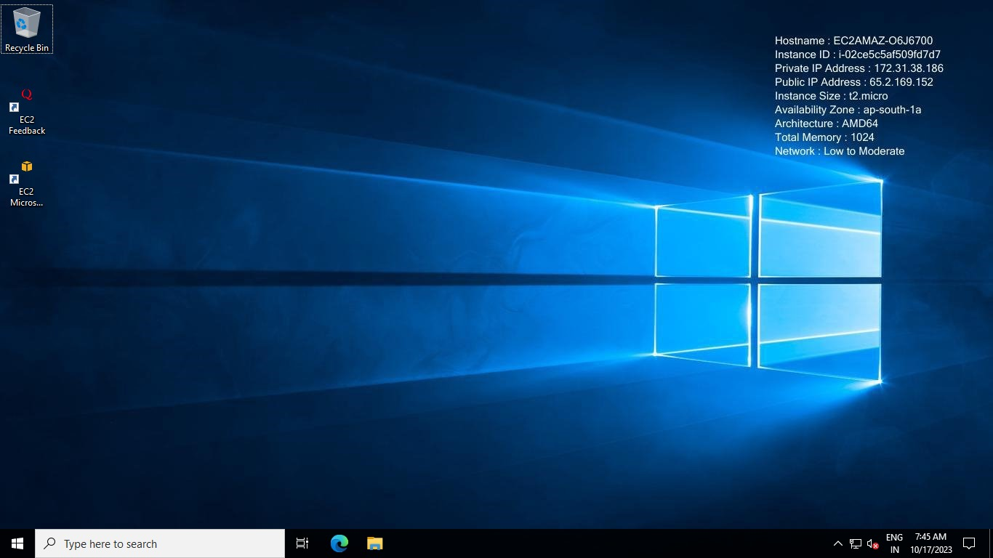

* Connect to windows server now
* Steps:

1) download the remote desktop

2) decrypt the password by giving the keypair.

3) enter the credentials and successfully login.

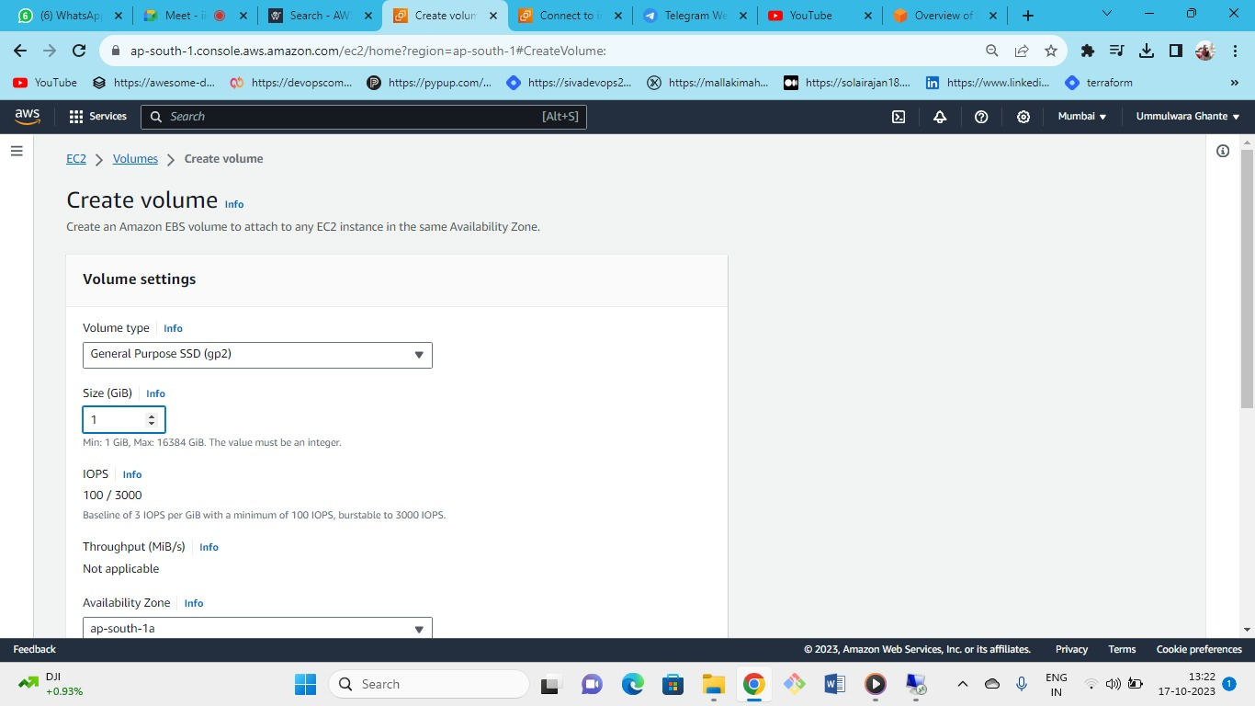



* Now create one extra volume for our windows server

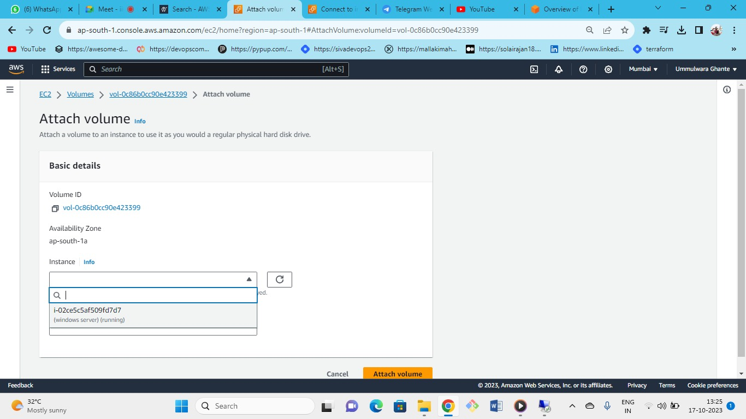



Now attach this volume to windows server.

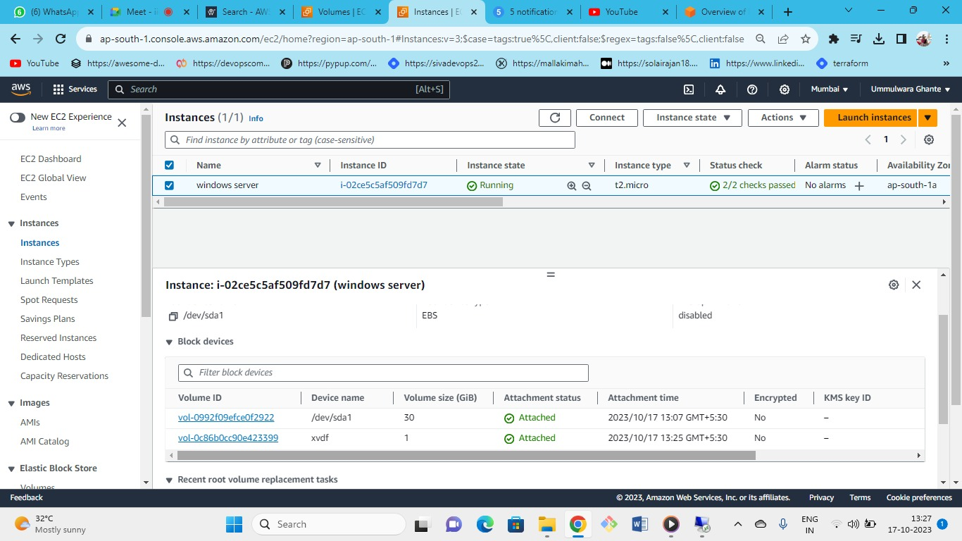



As we can see we have 2 volumes attached to our windows server

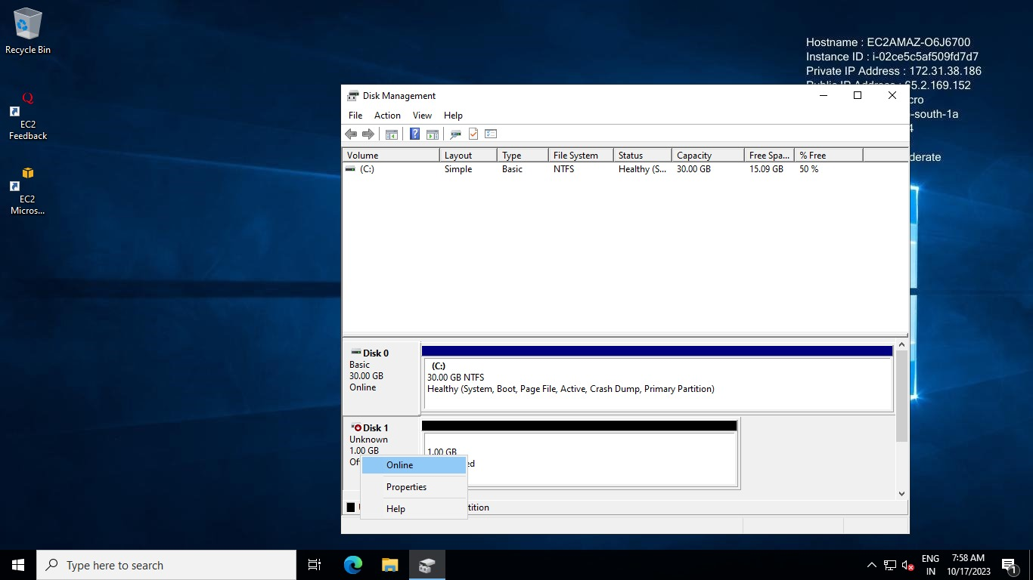

First make it online 🡪 Initializing 🡪 New simple volume

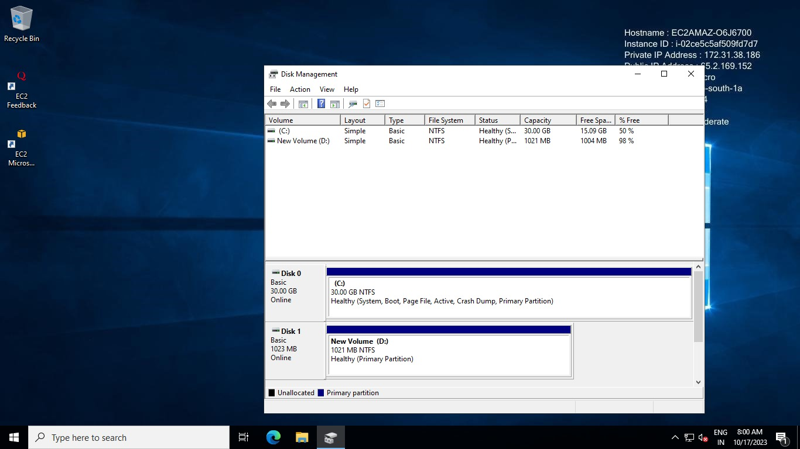

As we can see our newly created volume is online now

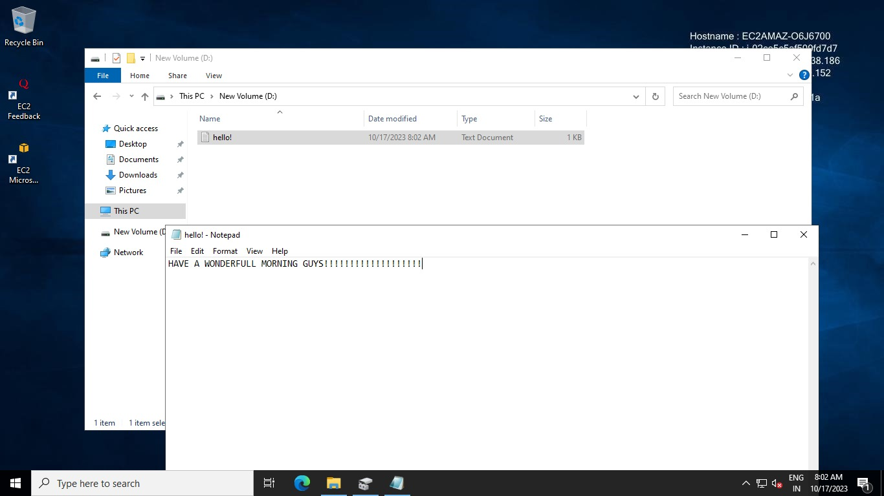

Now create one text document (e.g.: hello.txt) in the (**D-drive)** of volume

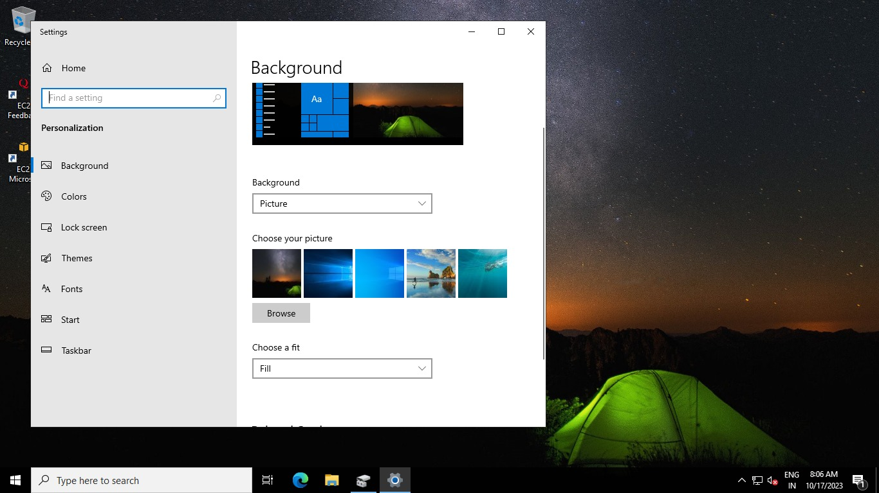

Right click🡪 personalize🡪change wallpaper of desktop so that we can identify our original windows server

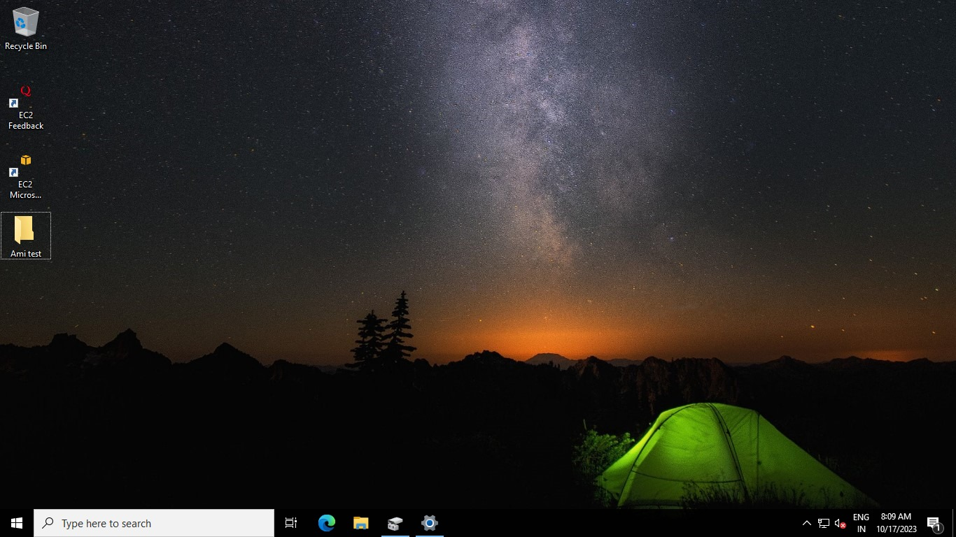

Create a new file on the desktop (e.g.: Ami test)

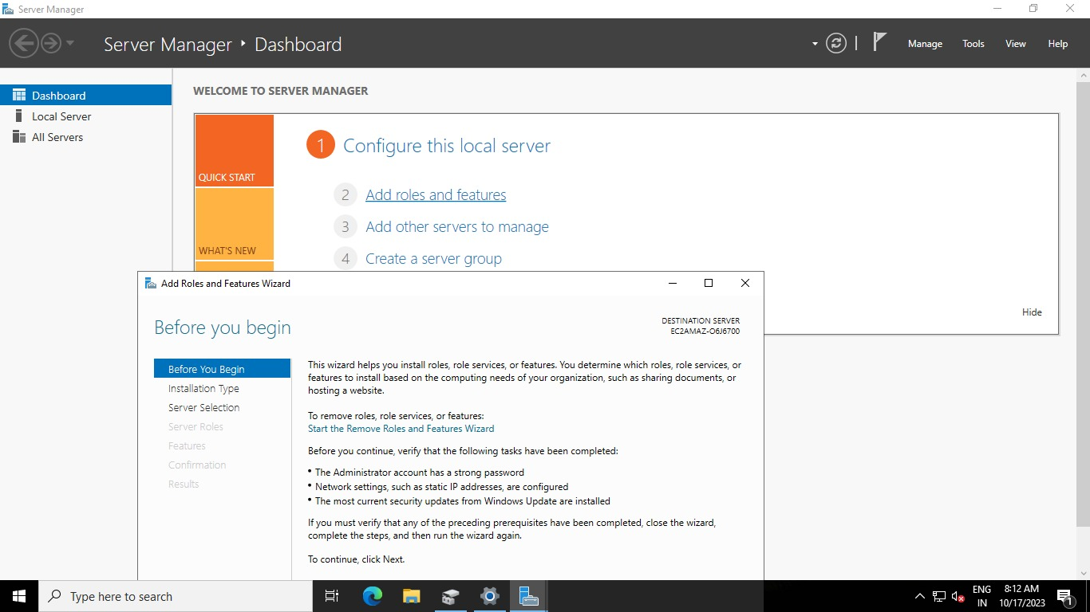

* Now create one web server ( IIS webserver)
* Click on Add Roles and Features.

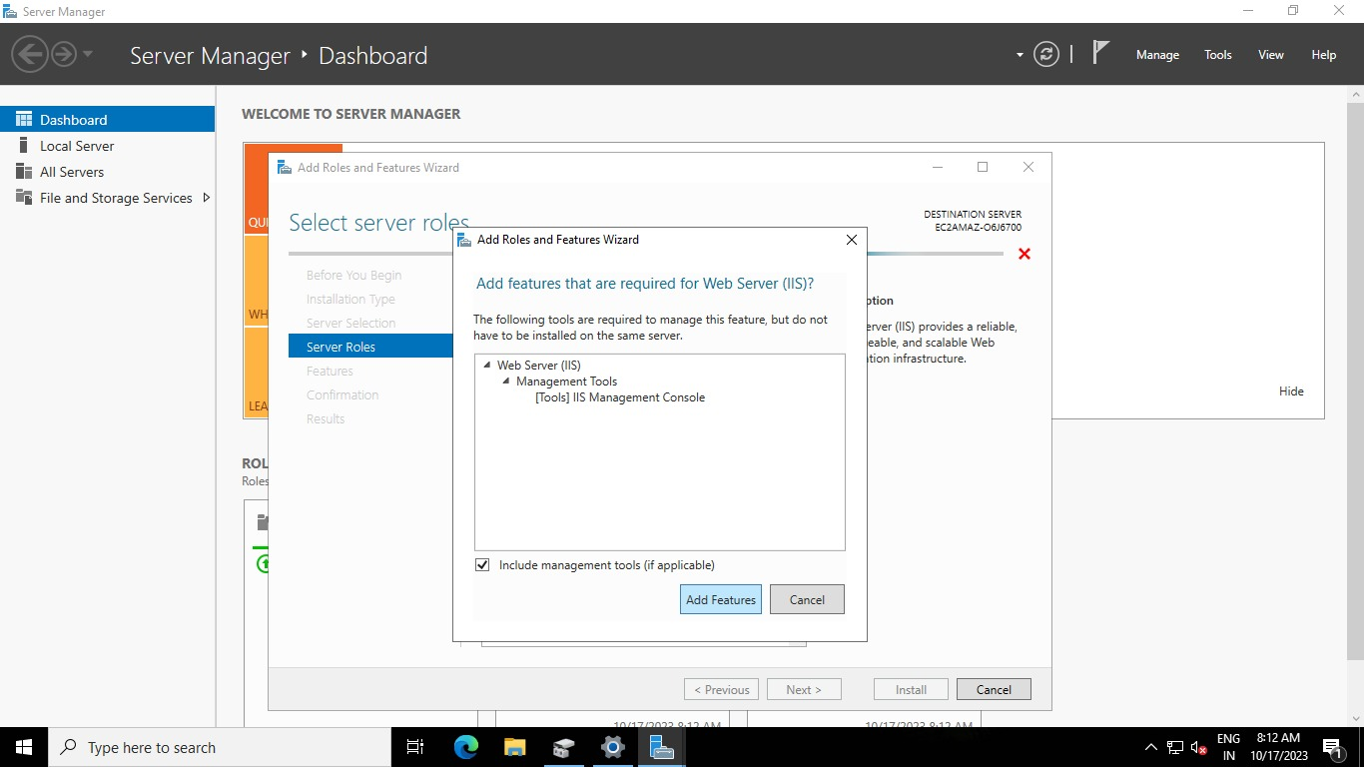

Select the IIS webserver and click on add features.

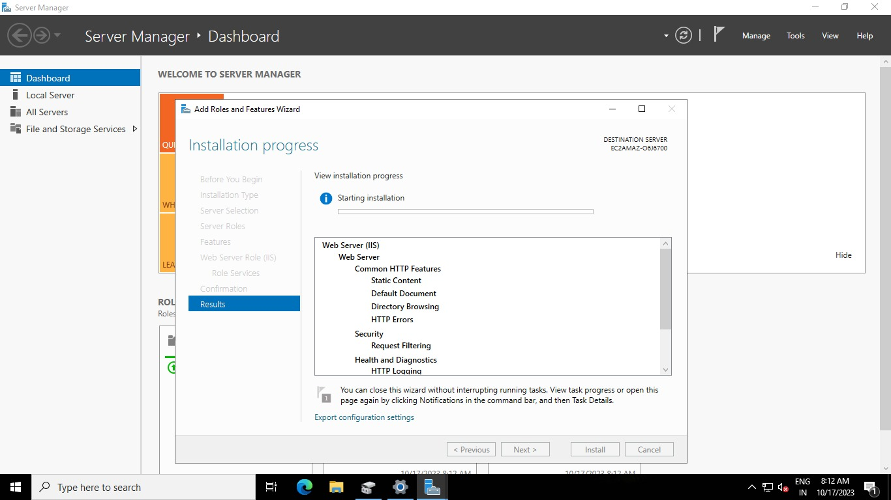

* As we can see our installation for IIS webserver has been started.
* For snapshot we selected volume but for AMI we will select server

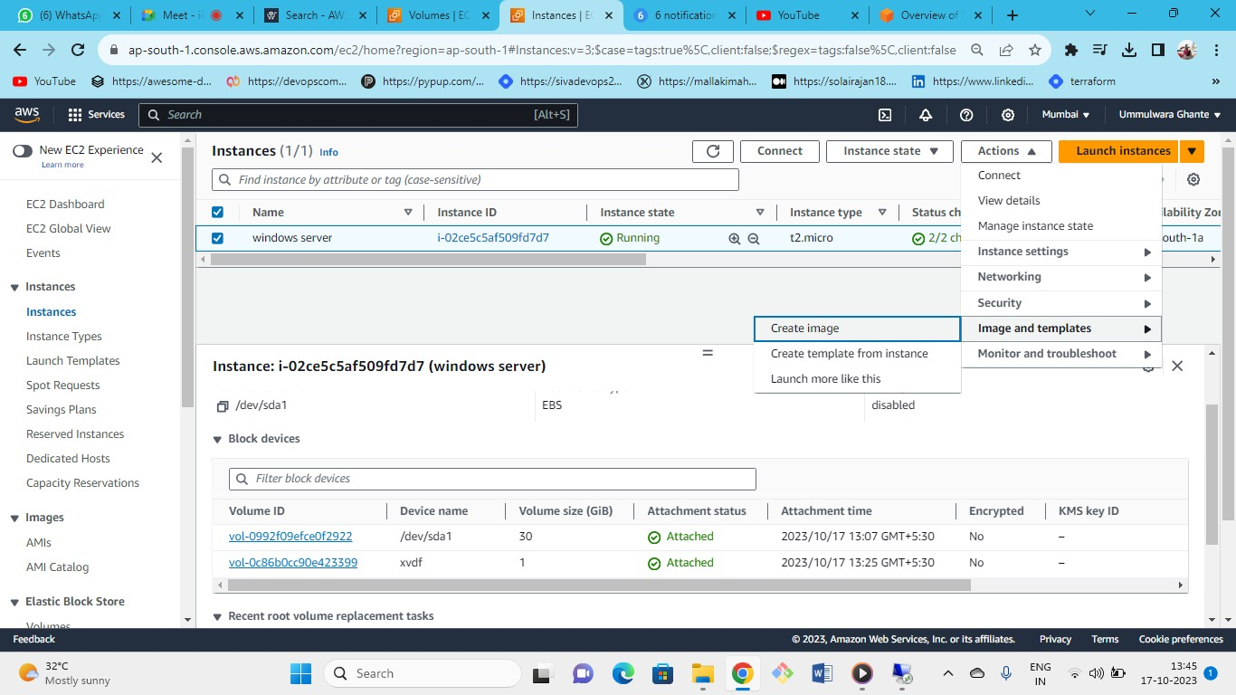



Now Create an image of the windows server.

Actions🡪Image and templates🡪Create Image

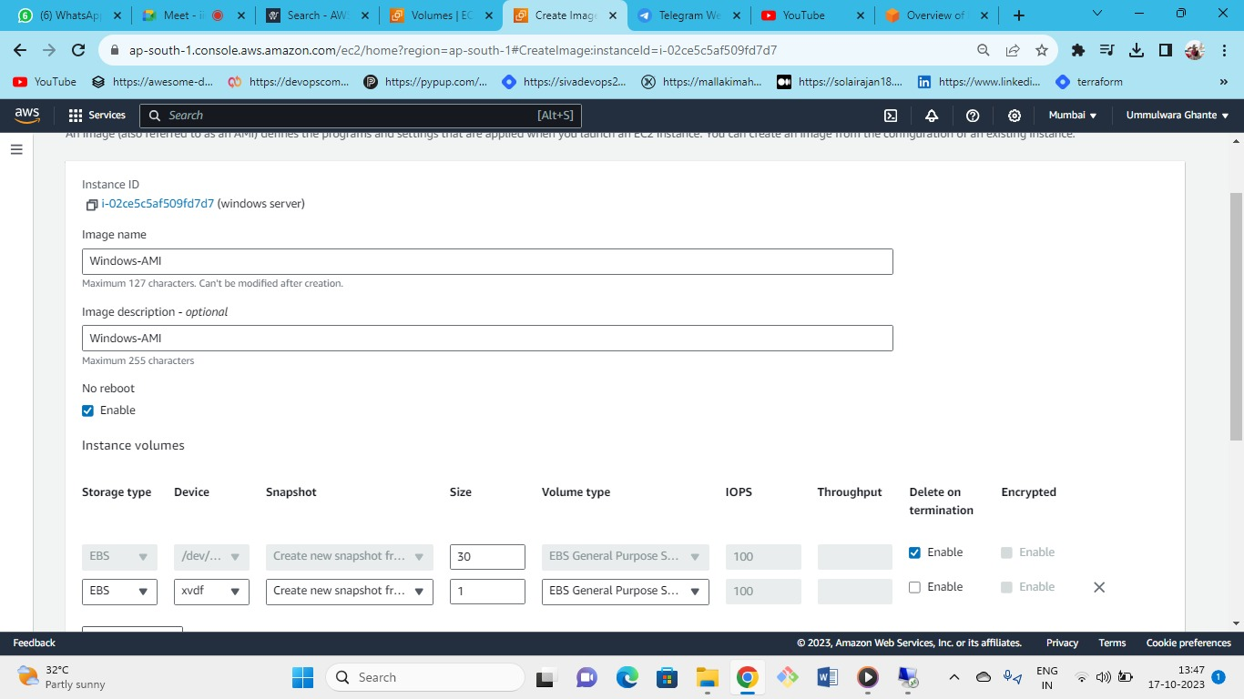



Give name for the AMI image that we will create and enable no reboot so that instance will not get rebooted.

No reboot option must be enabled for production purpose because if system reboots then all operations will be shutdown and lost.

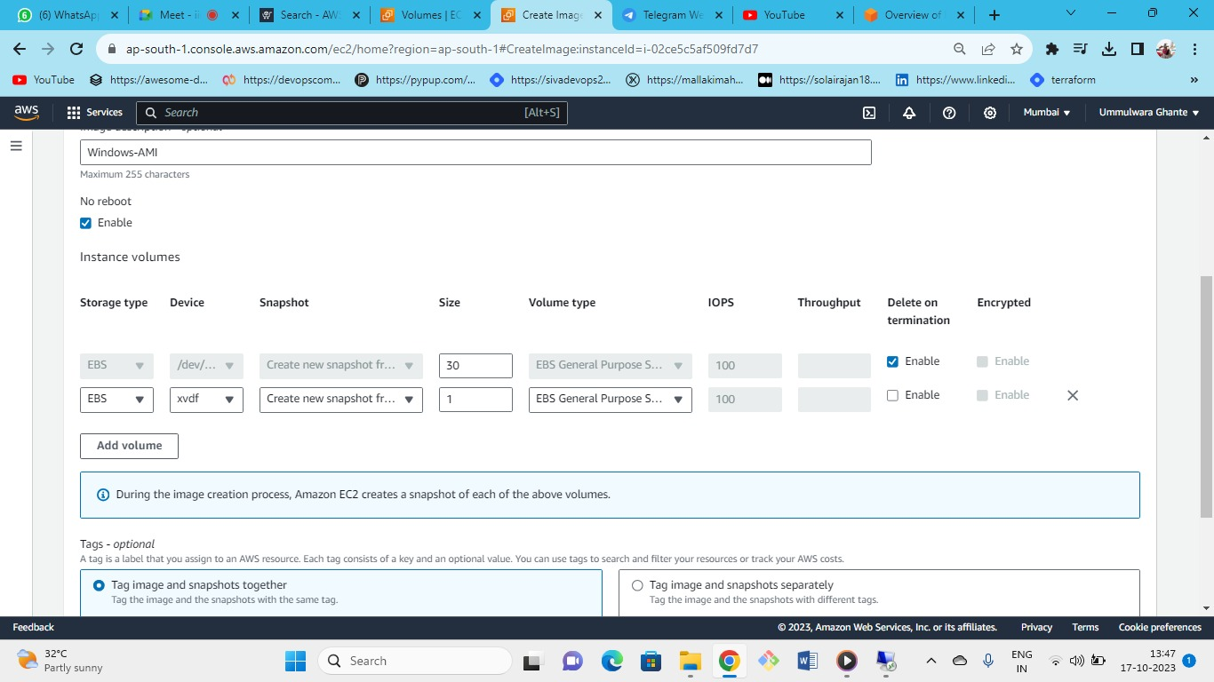



* Here you cannot modify the root volume but can add or remove the Additional volumes
* we can remove this additional volume too as when we restore the AMI then this volume will not be there
* when you will launch the server from this AMI then all this setting will be applicable to it.
* You can also enable or disable (delete on termination) option so that volume can get deleted when intance is terminated automatically.

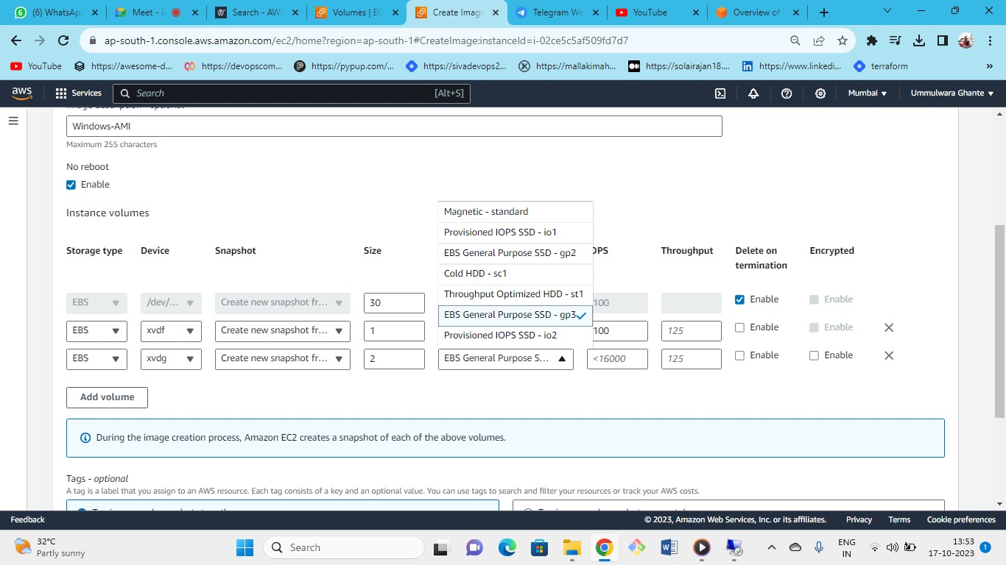



As we can see here, we have added additional 2 GB volume of GP3

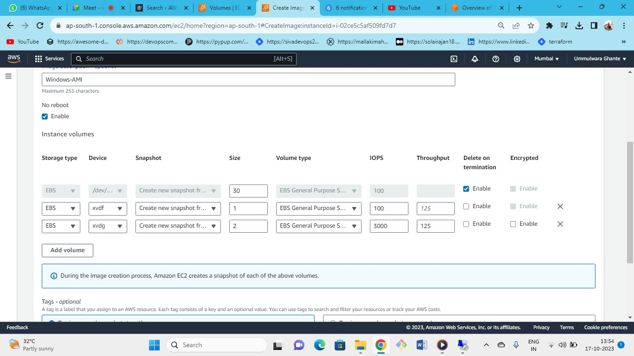



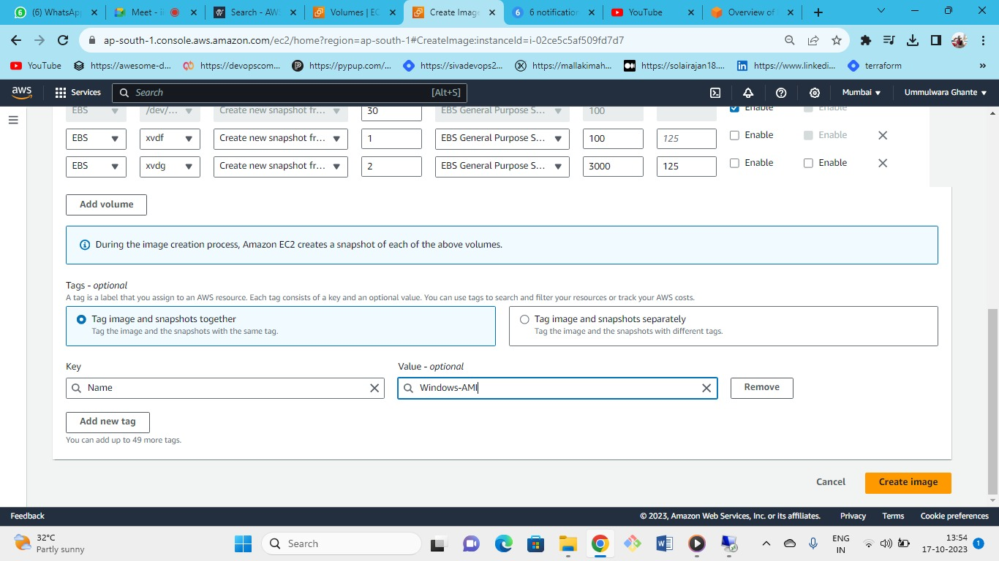



Note: Encryption is not enabled for the volumes created in image by original instance but if we add additional volume then we can encrypt it

* You can only modify the size of the root volume and termination permissions.
* Now click on create image

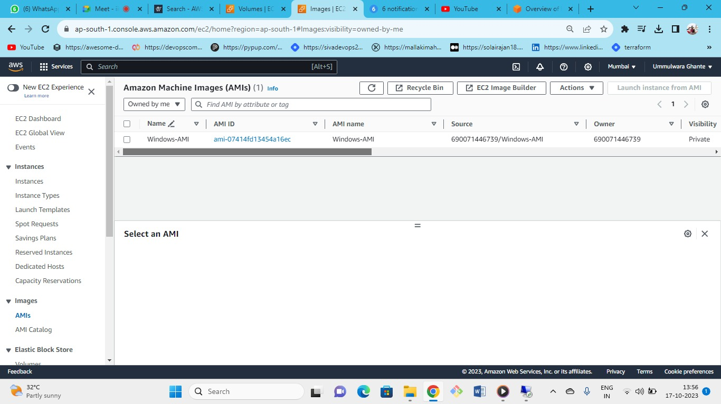



Image has been successfully created

**Note:**

As we have created an AMI from the server to launch it with another server but we have not changed the customized password as when we launch another server, we require a decrypted key+ Password + Username.

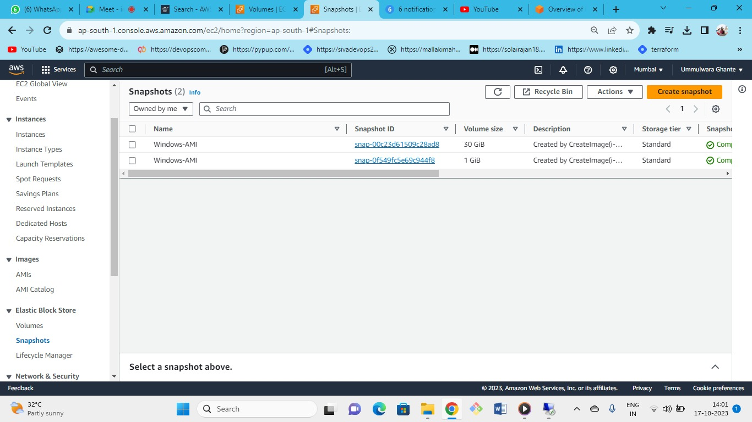



As you can see snapshots are being created for your volumes also the decryption is given by the AMI automatically.

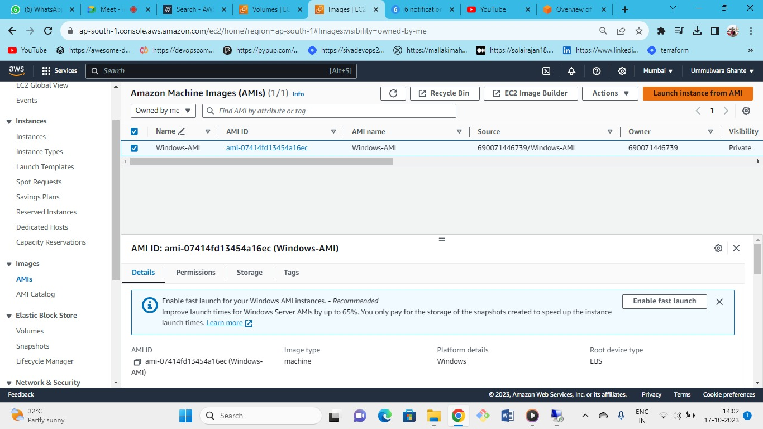



Launch instance from AMI

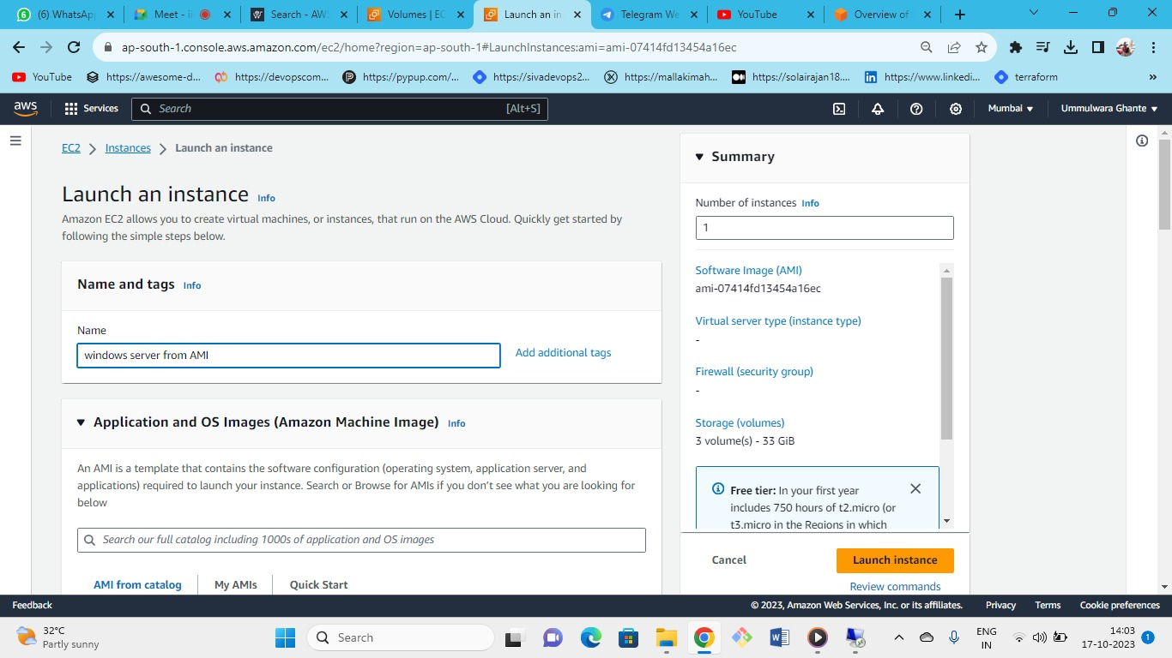



Give name to the new instance that you want to launch from the AMI

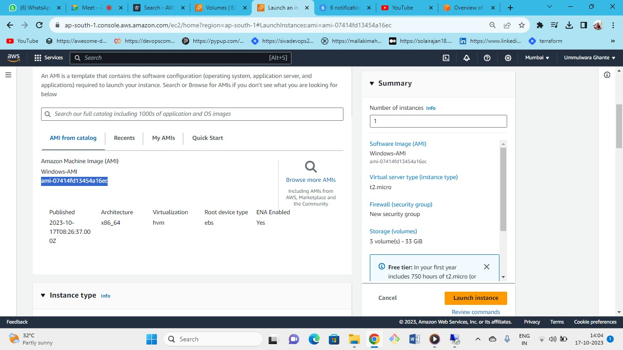



* This is the custom AMI
* Taking our own custom AMI not from the aws

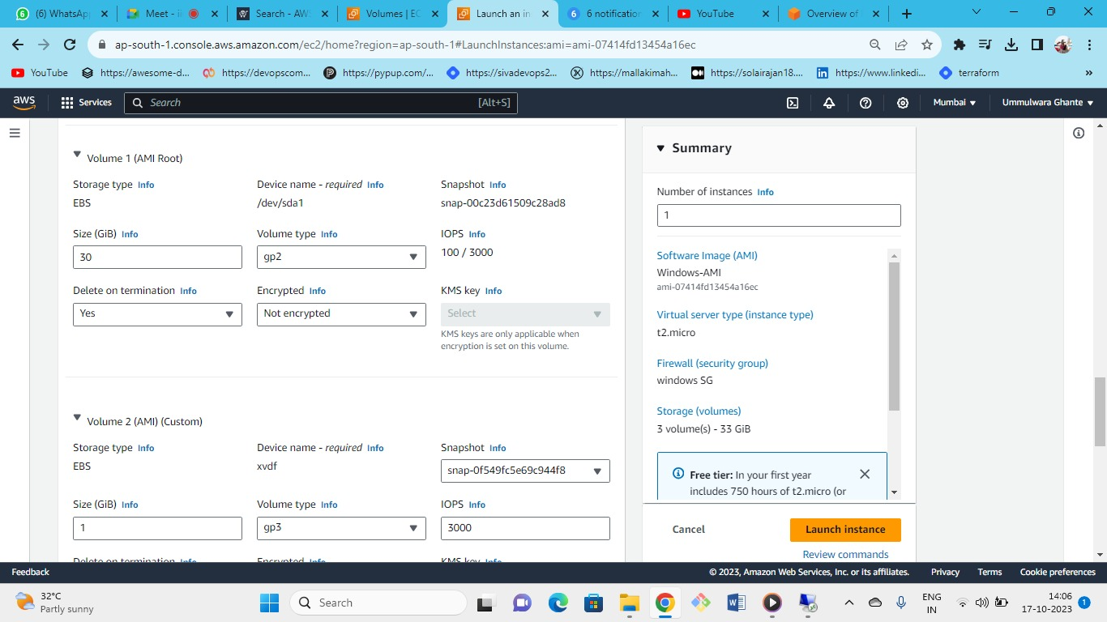



* All the settings for volume are automatic

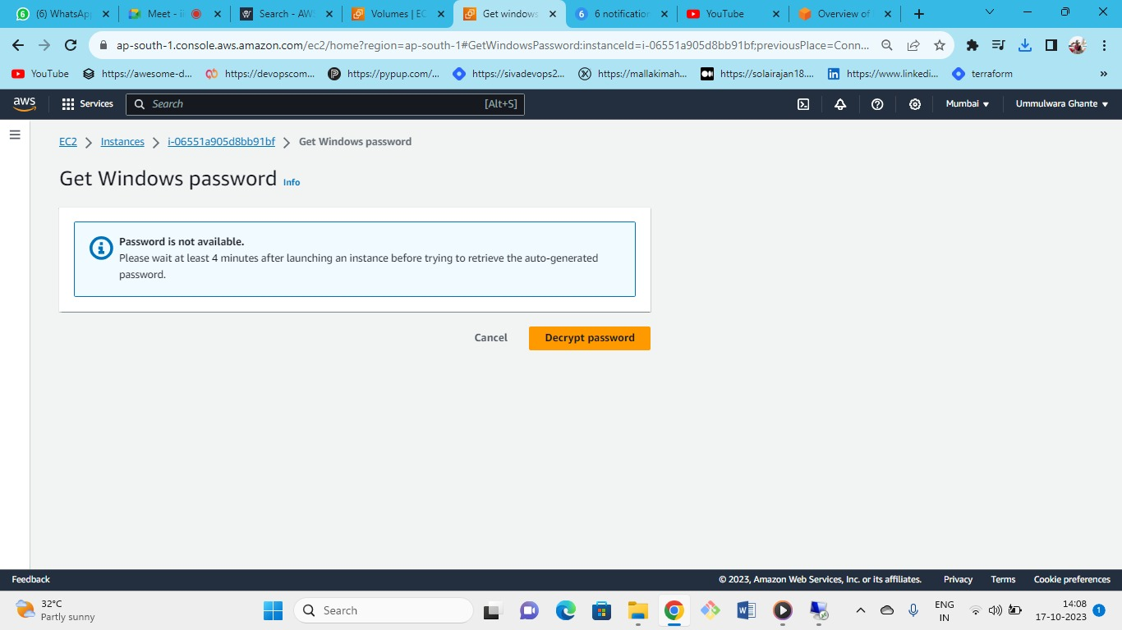



Now try to connect to the instance created from the AMI by Username and Password

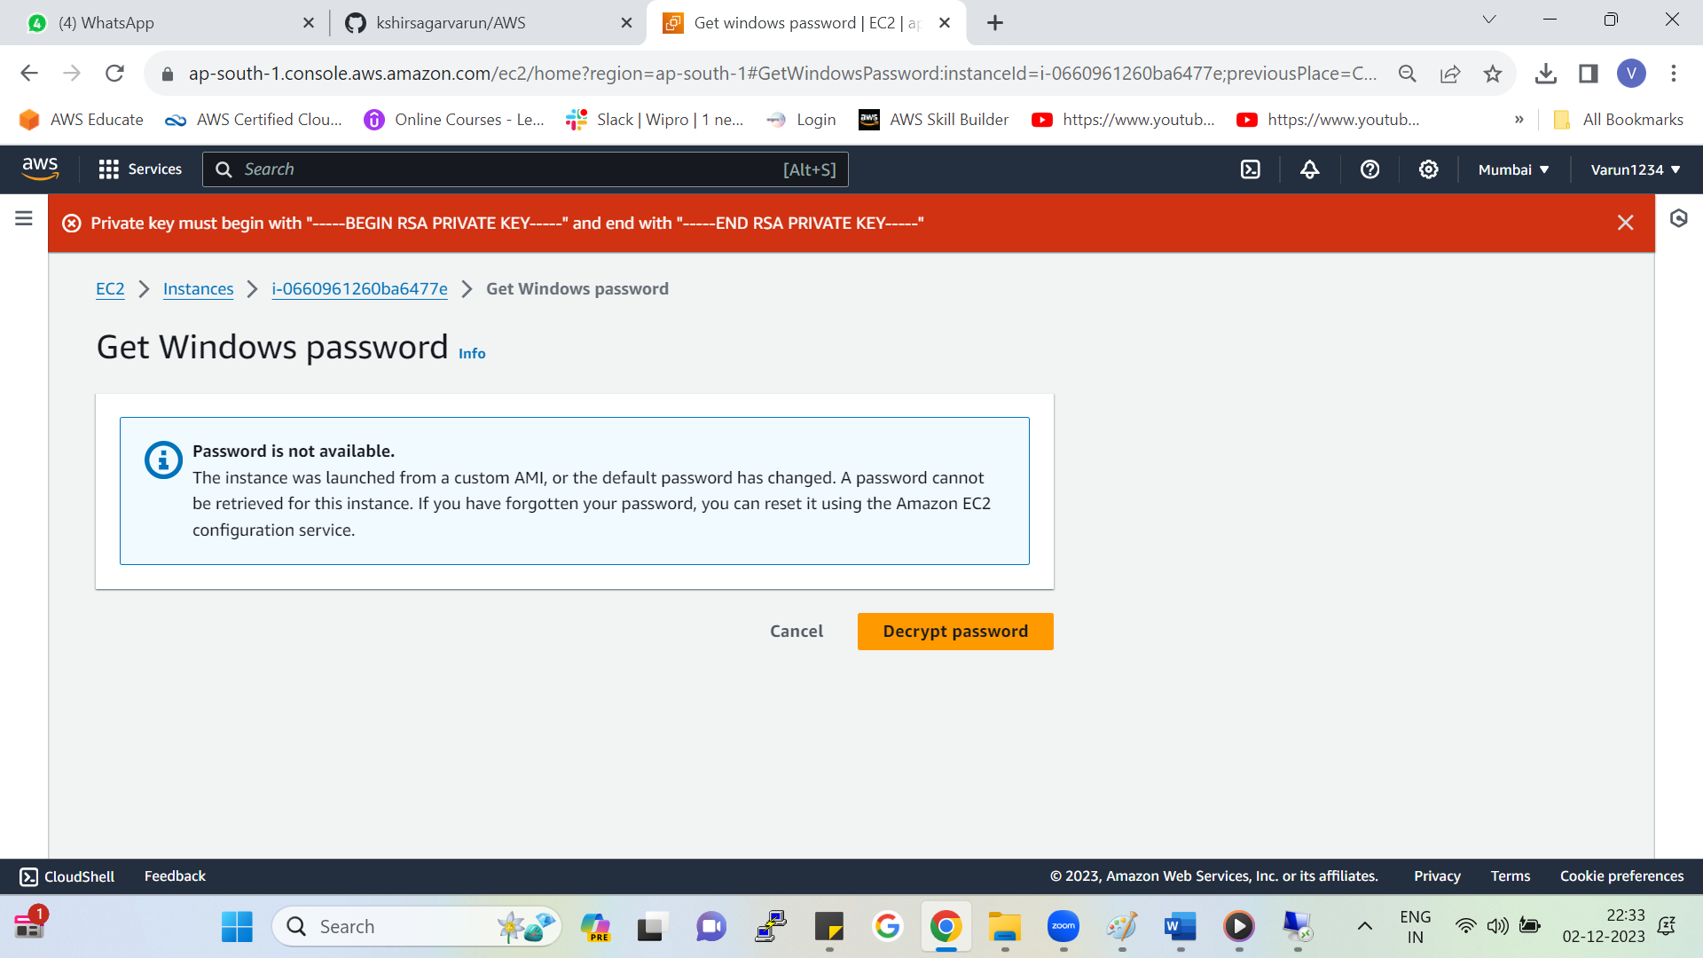



* We do not have any option to decrypt it and the timer will continue ticking.
* This is because this is not AWS provided AMI this is our custom AMI
* So to solve this problem we need to change the password of the administrator to custom password and then create AMI from that remember that password because AMI are also point in time copies like snapshot.
* But if you have decrypted password of your original server (i.e. windows server) then you can login to the instance created from the AMI even though if your original server gets terminated .
* But you cant decrypt the password this is possible only if you save the password in the notepad of your original server.

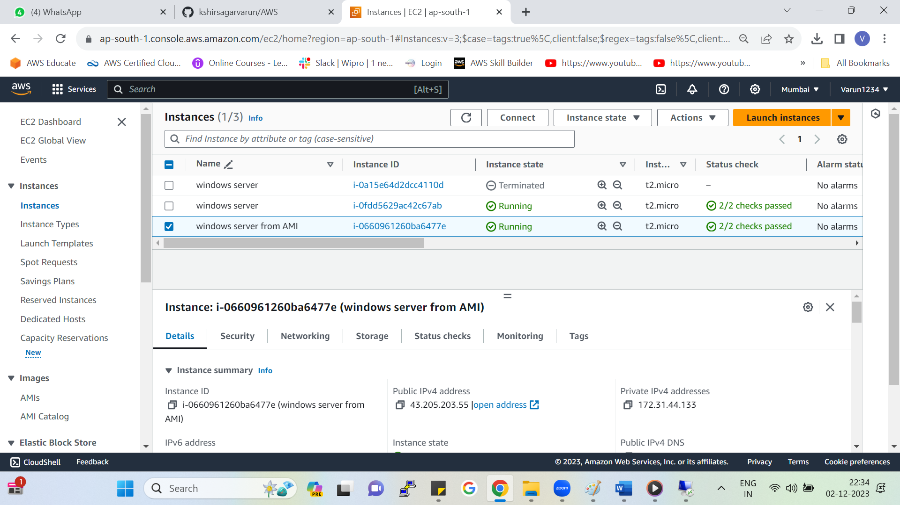



Now we will login to the AMI server by RDP with the decrypted password of original windows server.

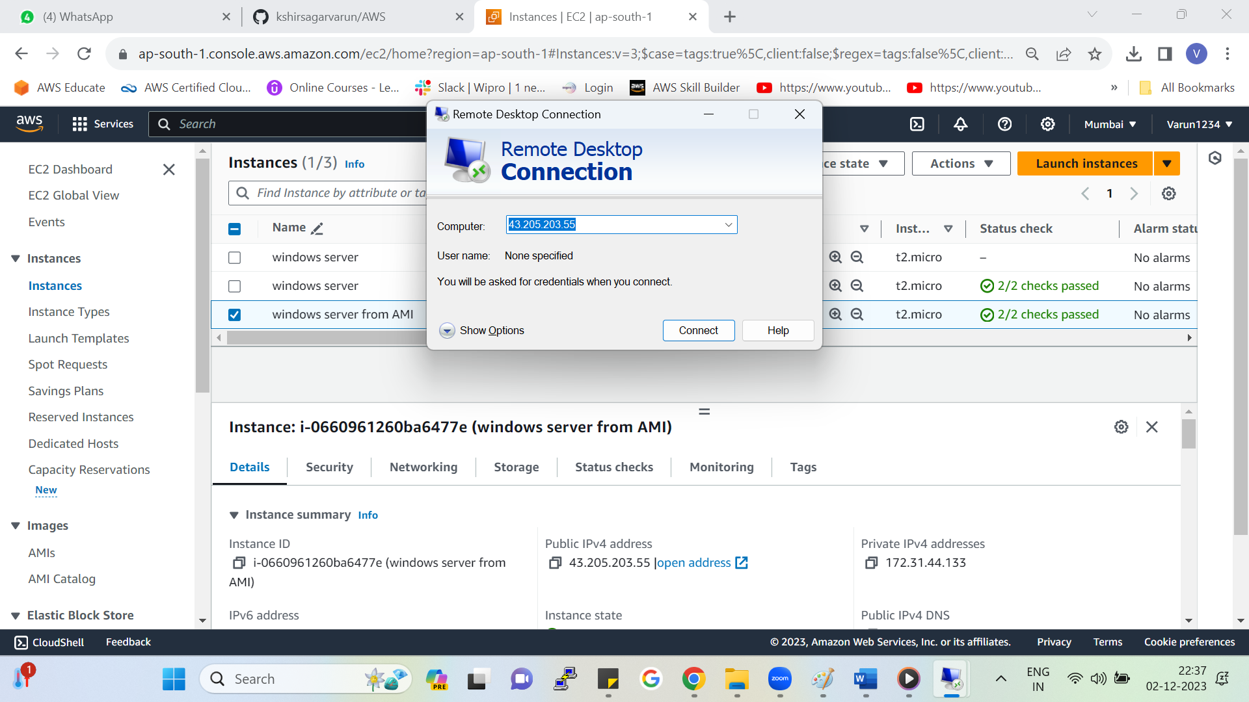



Put the Public IP of the AMI created instance and connect

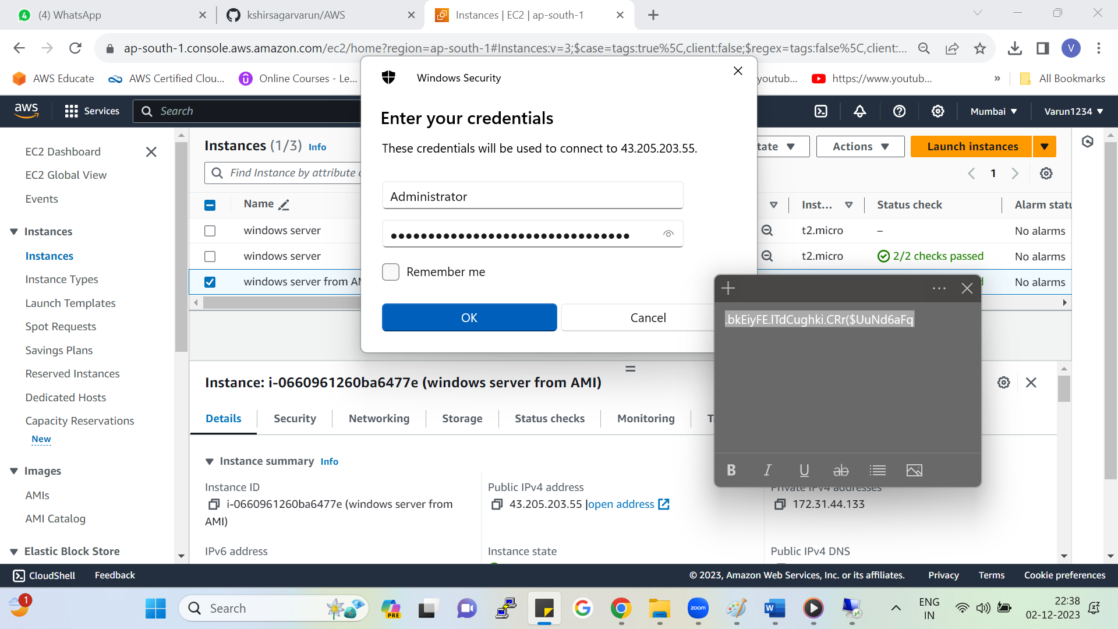



Put the saved password (i.e. Windows server password)

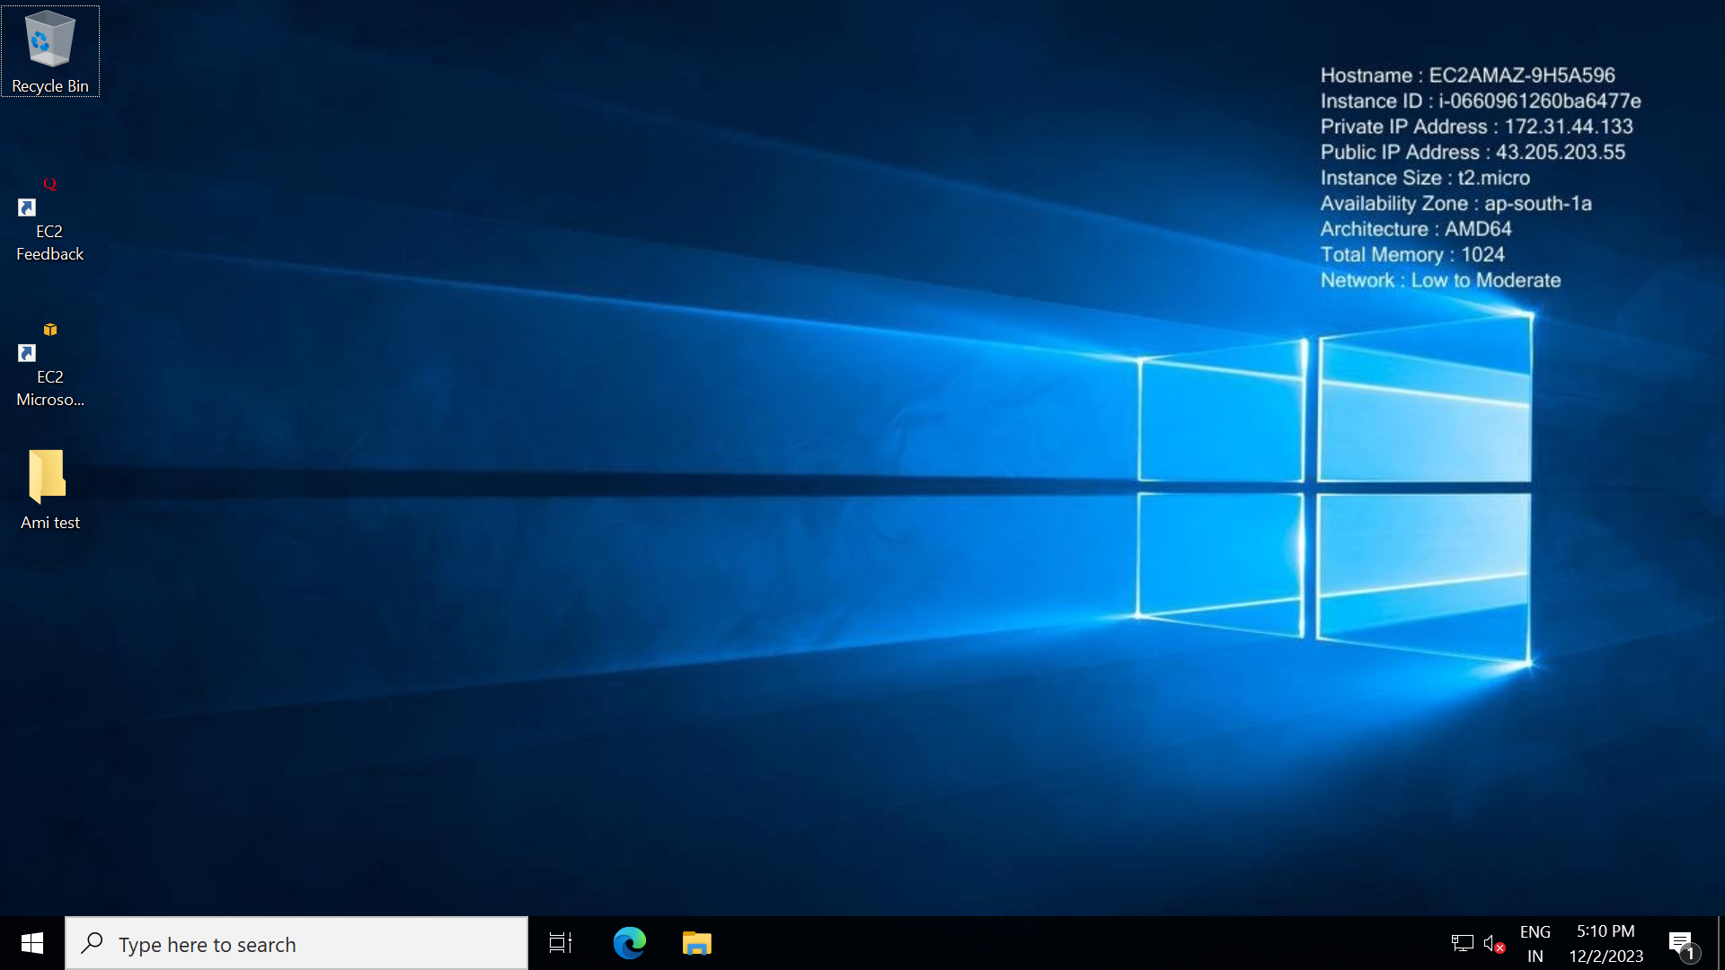

As we can see we are successfully able to login to our AMI created instance and our folder is also available

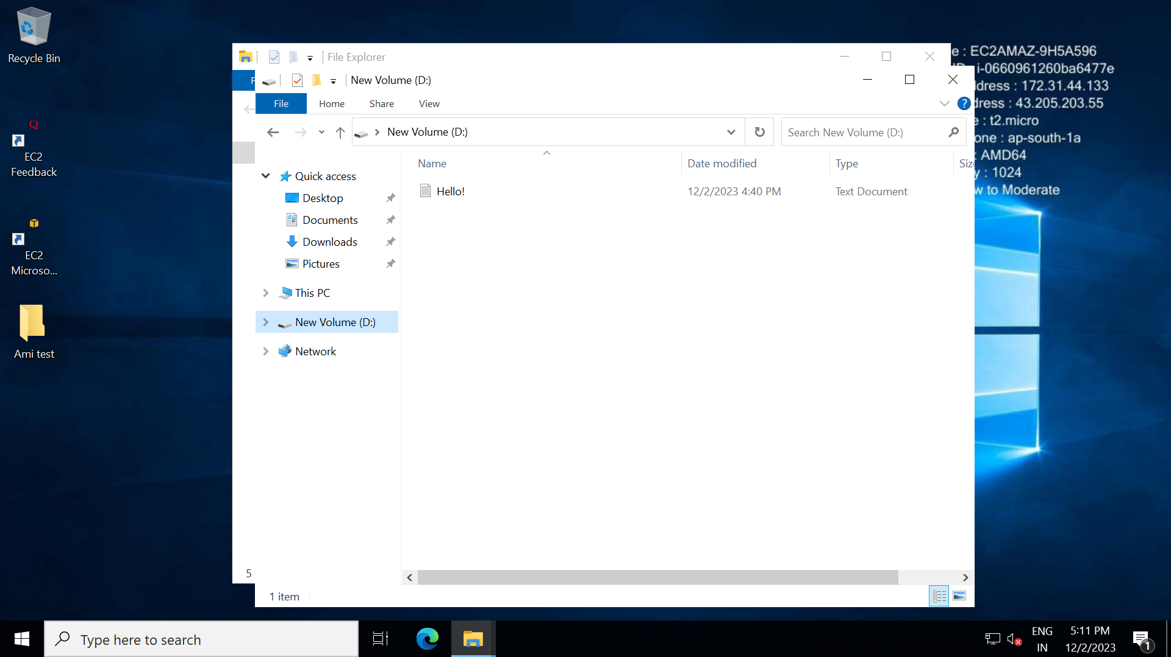

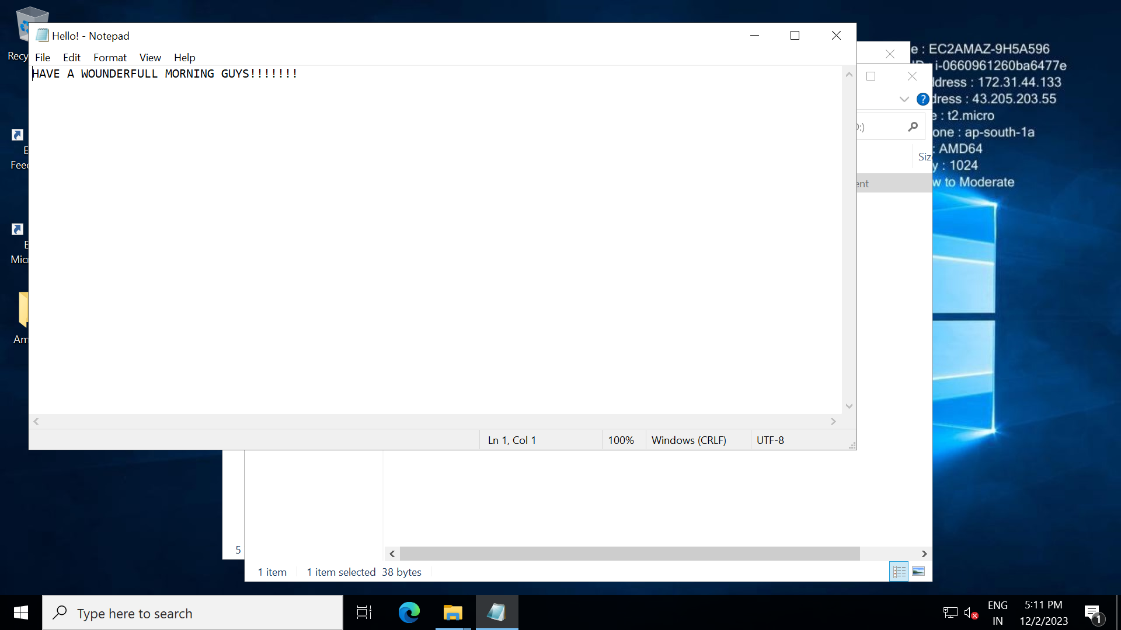

Also the file has been backed up into the new instance.

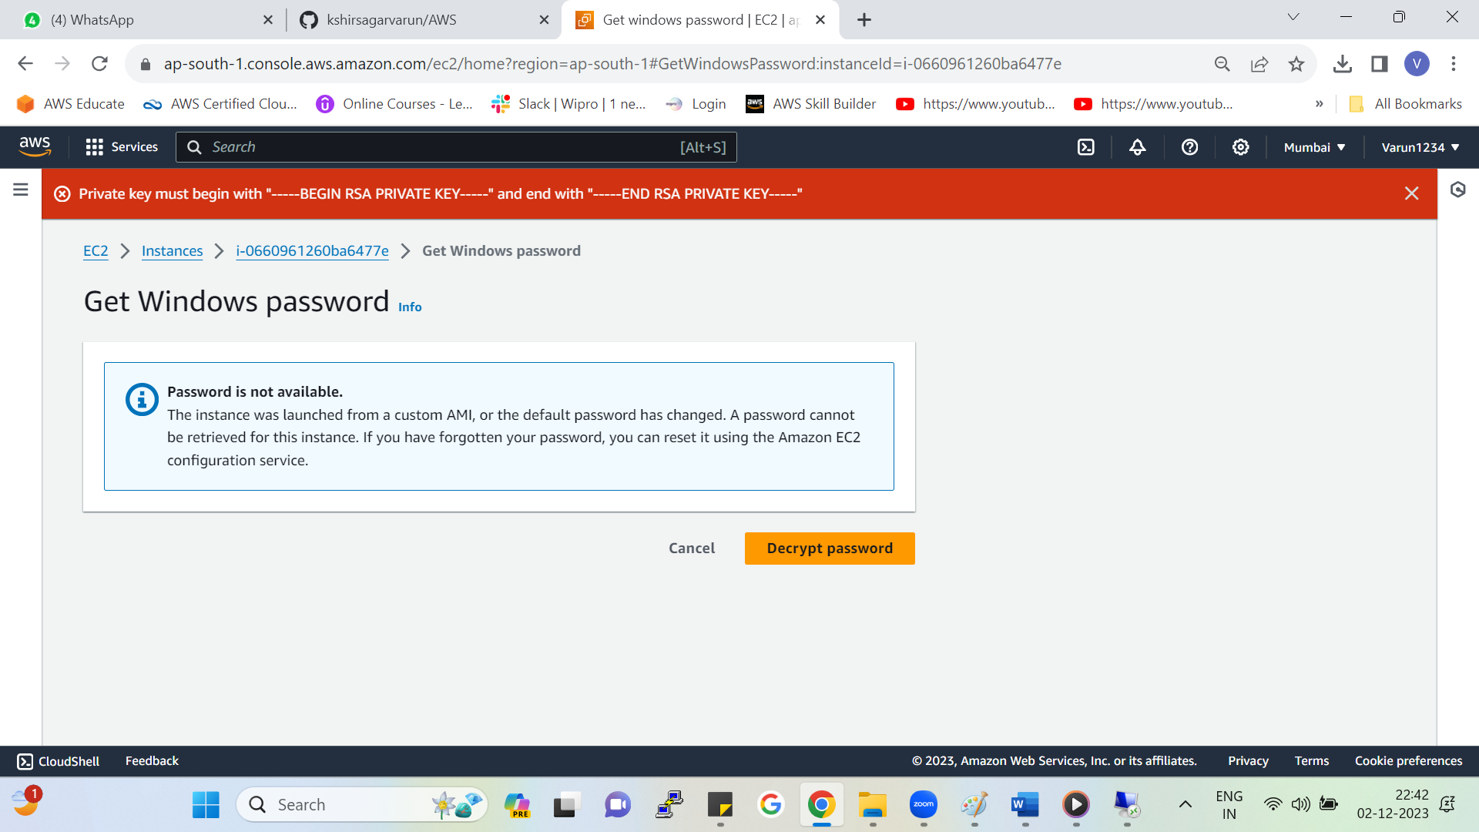



But even now I we try to login from decrypting password it is showing us error.

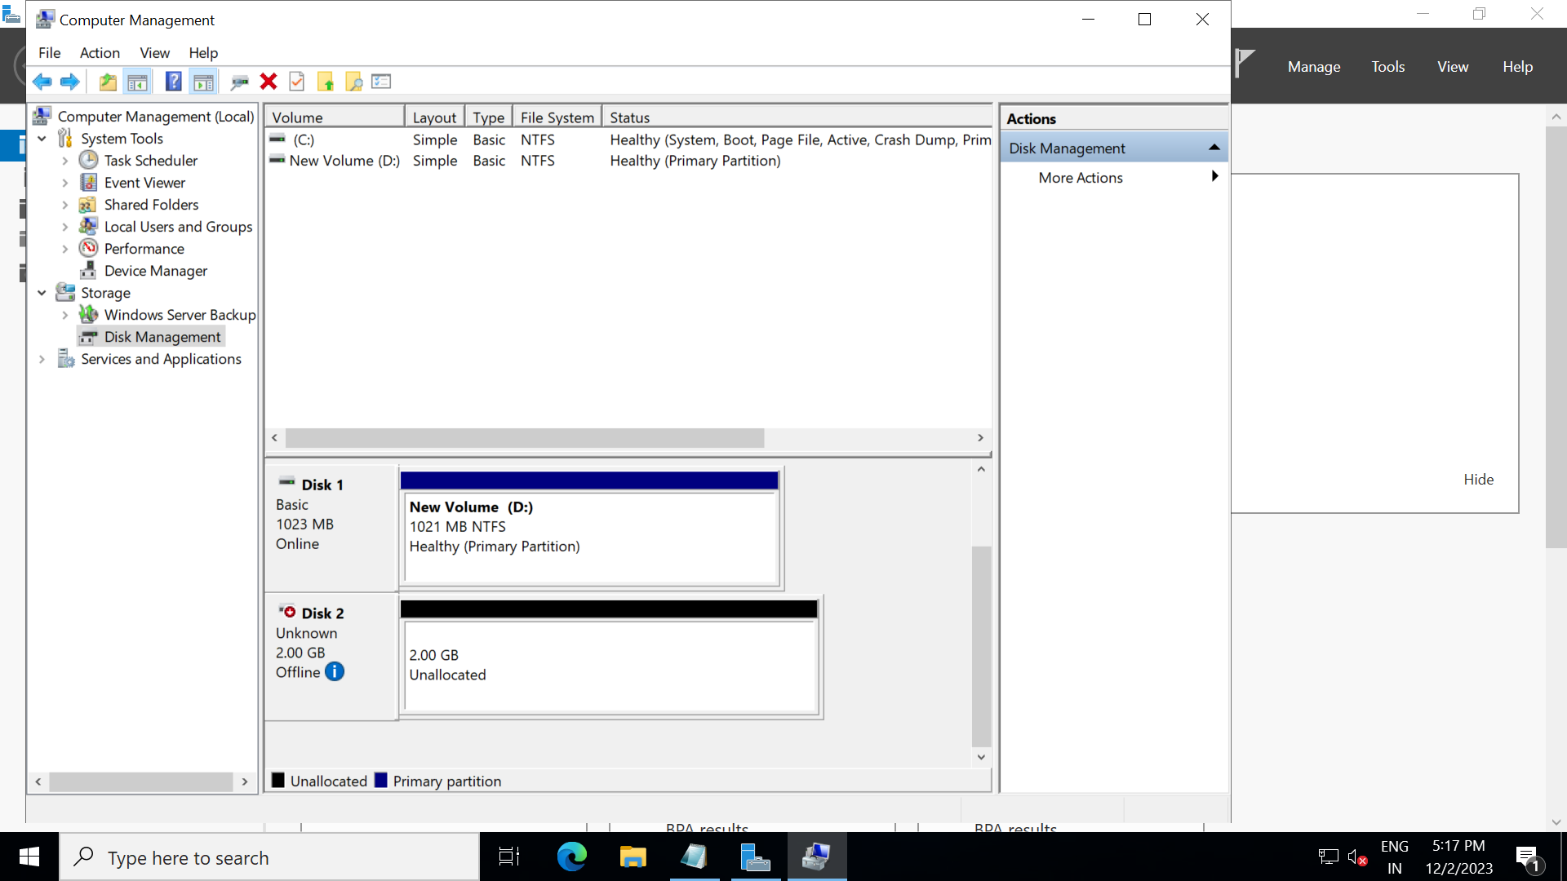

Also the new volume has been created to attach it make it online (i.e. 2GB volume)

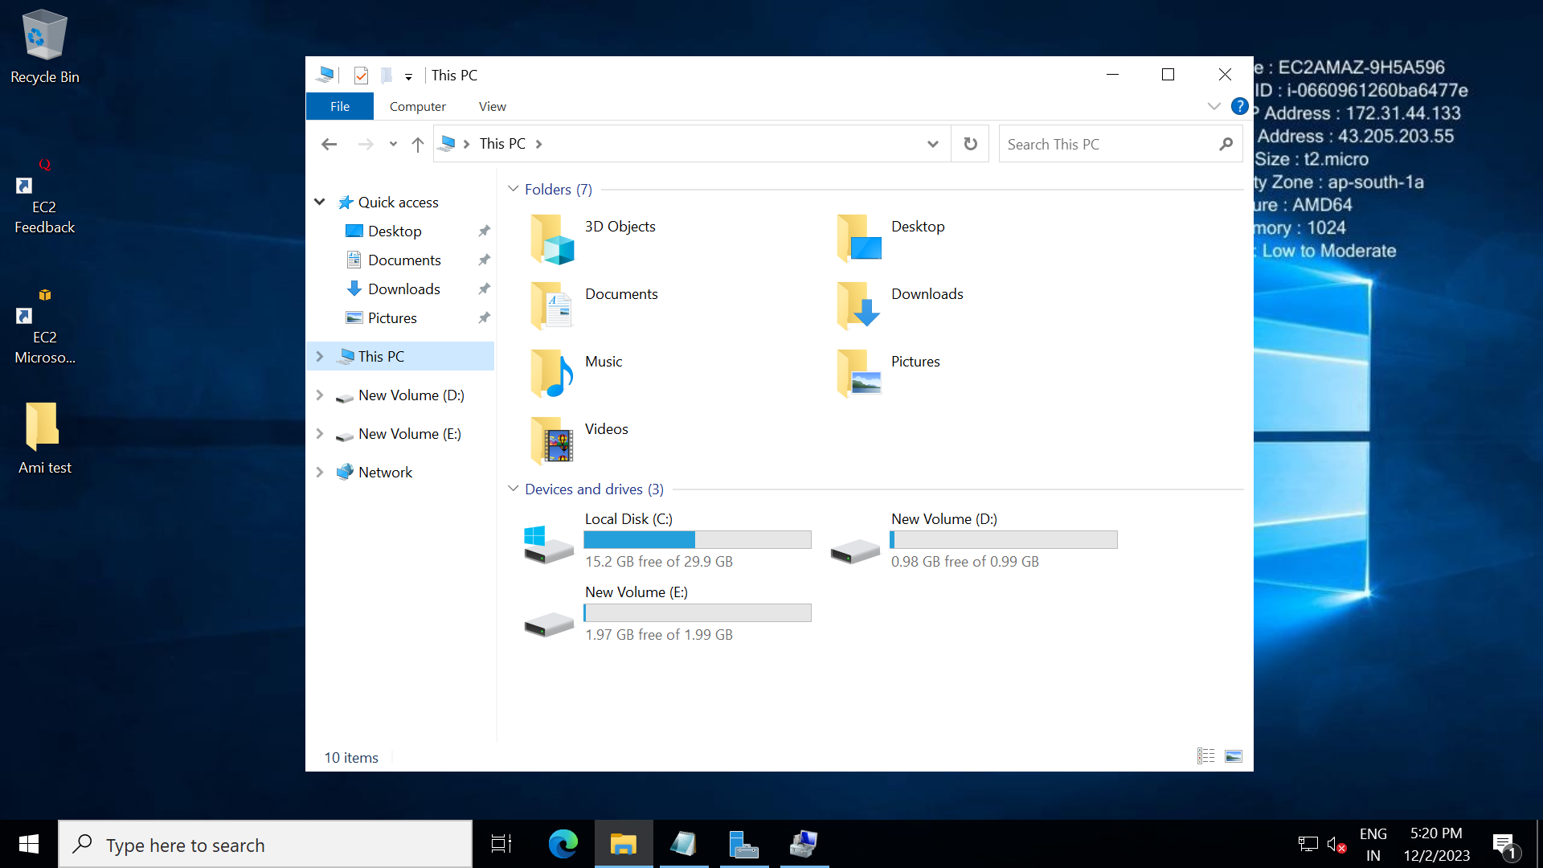

## To set Custom Password to login to the instance

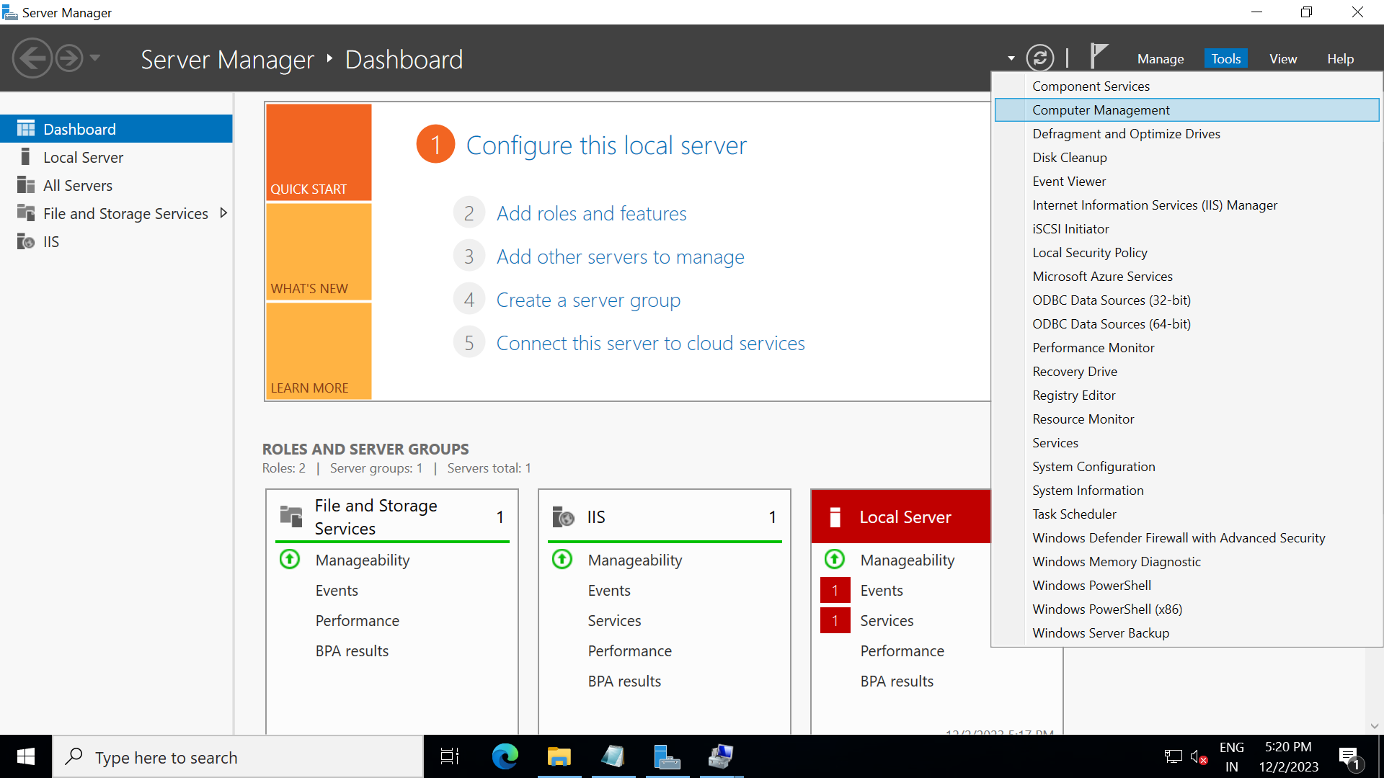

Server Manager 🡪 Go to computer management

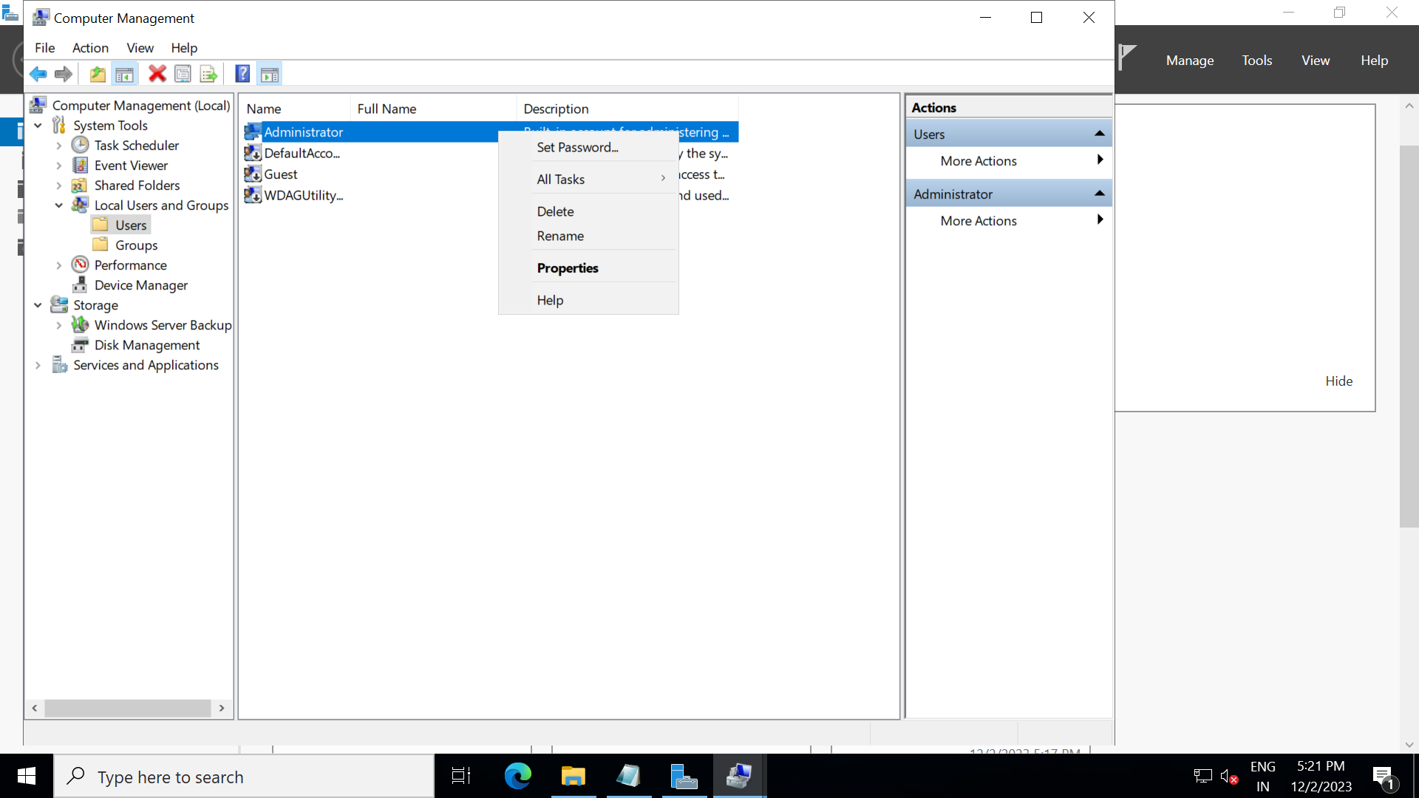

Local users and groups🡪users🡪right click and set your password

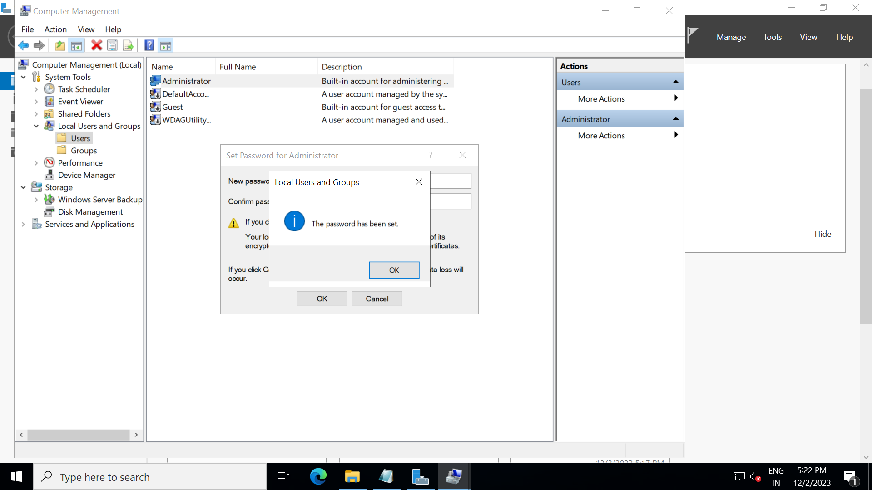

* Put your custom password
* Custom password has been set successfully.
* Now logout of your AMI created instance and try to login by custom password.

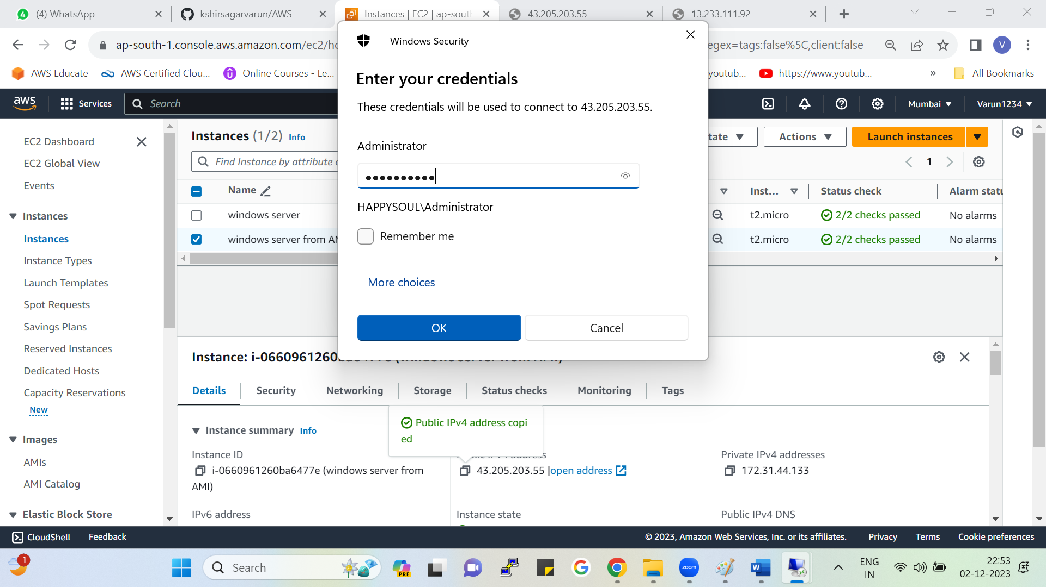



Login by custom password

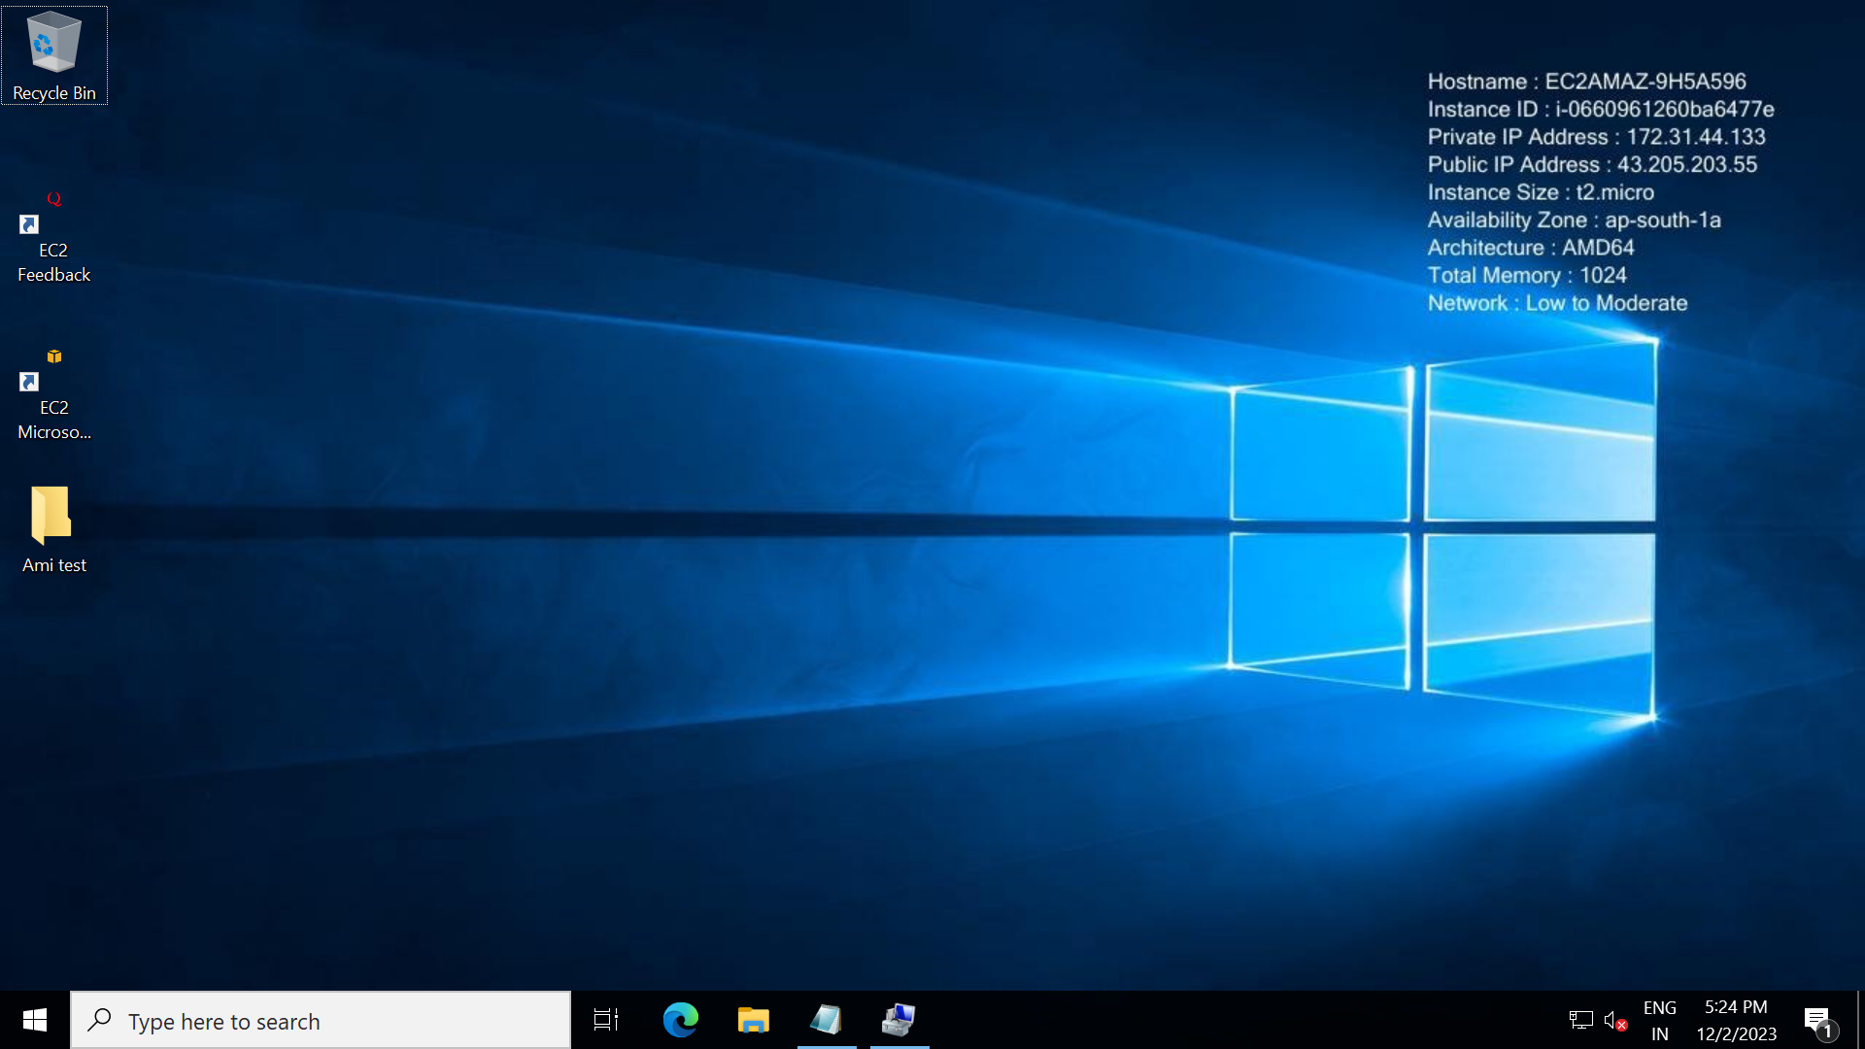

* Login to the AMI instance successful
* From this custom password method, we have no need to remember aws created password we just need to remember custom password and can login to the instance.